A Unique Excavation
Photo courtesy of the Texas Historical Commission
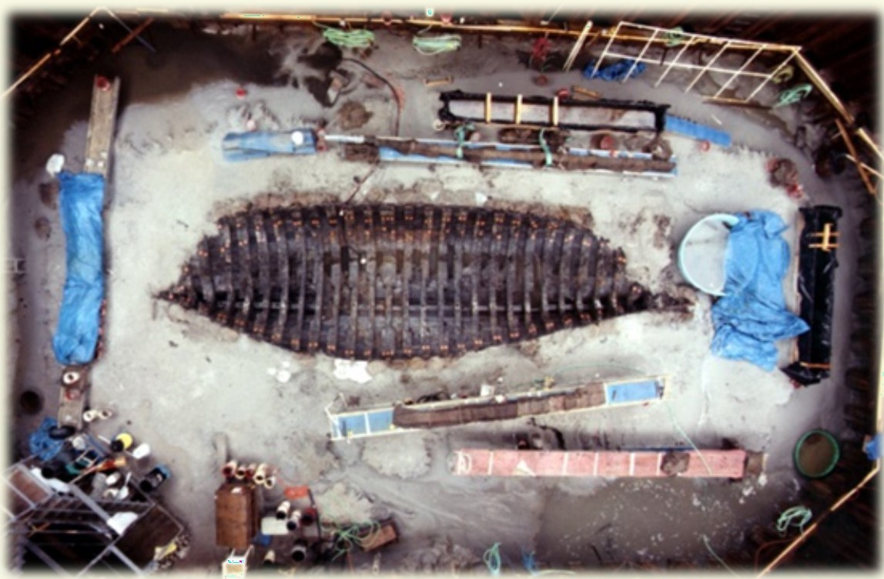
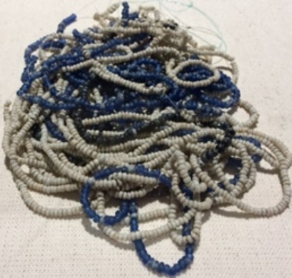
It was not until 1995 that archaeologists found wreckage of La Belle. The Texas Historical Commission quickly found out that the mud at the bottom of Matagorda Bay helped preserve 40% of the ship's hull and many of the artifacts contained within. In order to excavate the wreckage, workers constructed a cofferdam around the ship, and drained the water that covered the ship. This process allowed archaeologists to work on the ship in the same way they would on land. Some of the artifacts excavated from La Belle, including beads, shot, a fire pot, rings, and a dice, can be viewed at the museum. What would you have taken on a voyage across the Atlantic?

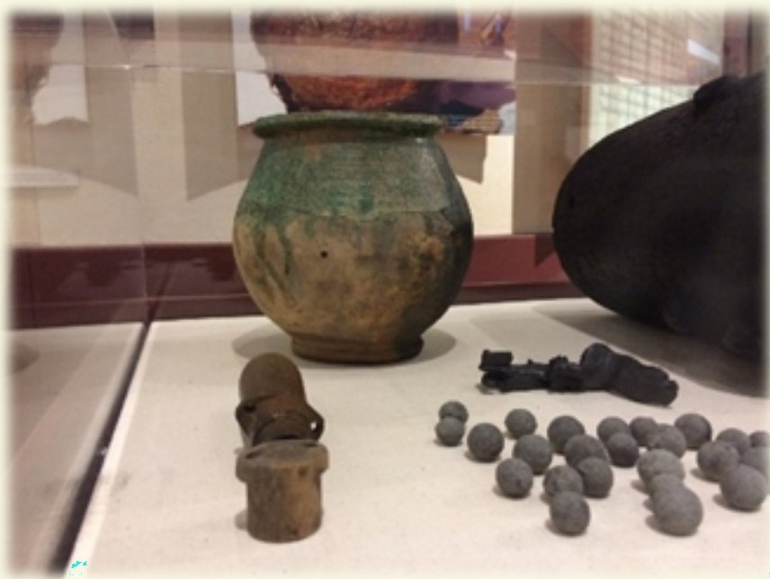
La Belle became one of the largest conservation projects undertaken in the United States, because the ship and the artifacts all needed special care. When it was time to remove the wrecked ship from Matagorda Bay, archaeologists dismantled the hull plank by plank and transported it to the Conservation Research Laboratory at Texas A&M. Conservators used special methods to preserve the hull and all the artifacts recovered.

