French Exploration: La Salle’s Expedition

René Robert Cavelier, Sieur de la Salle left France in 1864 with four ships: La Belle, Le Joly, l'Aimable, and Saint François, and set out for the Mississippi River. La Salle missed the Mississippi River and ended up off the Texas coast. This error is not surprising due to the navigation equipment at the time of La Salle's voyage. It was relatively easy to calculate latitude. Longitude was much harder to calculate while at sea because timepieces of the 1600s used pendulums, which were not reliable on choppy waters.
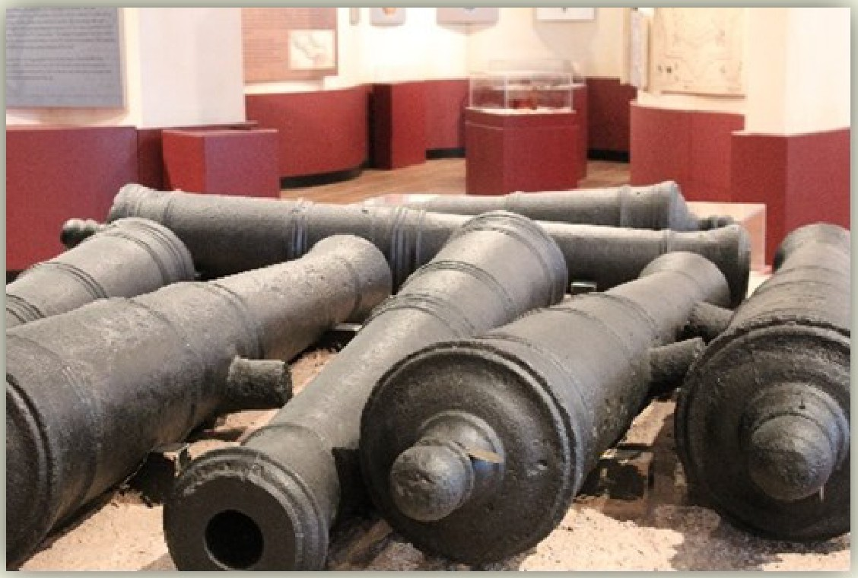
When La Salle arrived at Matagorda Bay, only three ships remained because privateers stole Saint François in the Caribbean. Shortly after arriving off the Texas coast, La Salle lost l'Aimable. La Salle attempted to lighten the ship's load by removing the cannons, now located at the center of the museum,
and other supplies; however, l'Aimable ran aground. After losing l'Aimable, Le Joly returned to France, carrying some of the colonists and supplies, leaving only La Belle and 180 colonists in Texas.
La Salle built a temporary camp called Fort Saint Louis. While at the camp, La Salle continued his search for the Mississippi River. During one of these expeditions, a strong wind blew in while the captain had La Belle's anchor raised, and the ship ran aground.
The people who remained at the fort lacked supplies and could not survive, and La Salle's men mutinied and killed him during one of their searches for the Mississippi River.
Eventually the Spanish found the remains of Fort Saint Louis and years later built a presidio in its place.

