The Karankawa, Peoples of the Coast

The Karankawa lived in the coastal area of Texas until the mid-18oos, and they were the Native Americans that the Spanish and the French came into contact with when they reached the Texas coast. The name Karankawa refers to five different groups connected by language. They were a nomadic people who moved between the coastal regions during the fall and winter to approximately 30 miles inland during the spring and the summer. While not a maritime people, the Karankawa relied on
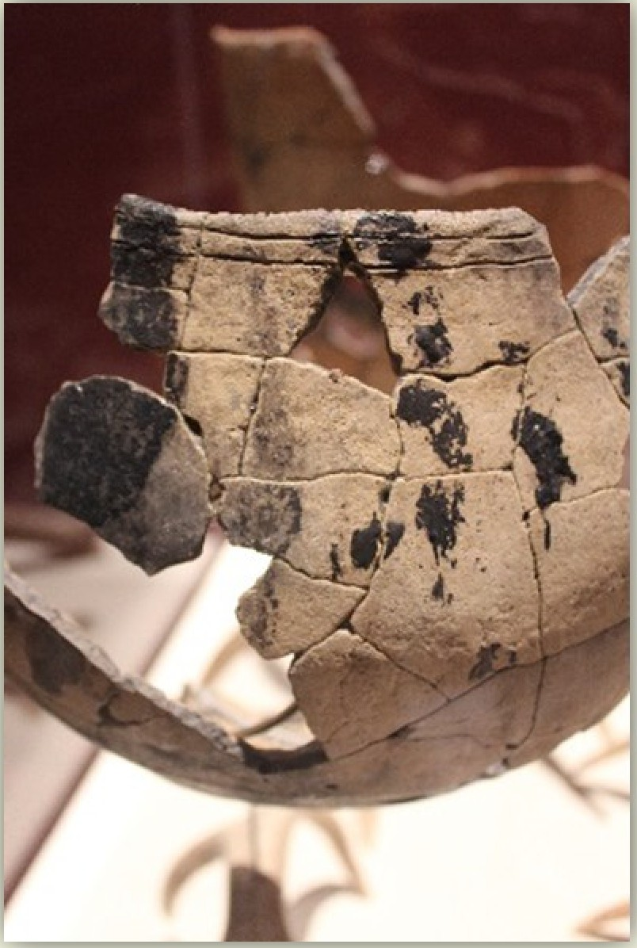
the ample fish and shellfish of the Gulf Coast.

The Karankawa are known for utilizing a style of pottery that, today, is referred to as Rockport pottery. This pottery often features asphaltum, a form of natural beach tar, designs on various parts of the pot and/or incised lines around the tops of the pots. Asphaltum was also used to water-proof the interiors of some pots. All Rockport pots have a curved base in order to sit directly in cooking fires. The museum has several partially reconstructed Karankawan pots on display.
There are several records, from the Spanish, French and Anglo Americans who settled this area that recount the physical appearance of the Karankawa. Descriptions of the Karankawa included details of tall and muscular men with tattooed bodies, pierced nipples and lower lips, and sometimes wearing a breechcloth. Accounts described Karankawan women as having painted bodies and skirts of animal skin. The cultural aspects of the Karankawa were either not very detailed or not recorded, and historians and archaeologists still work to learn more about the Karankawa.

