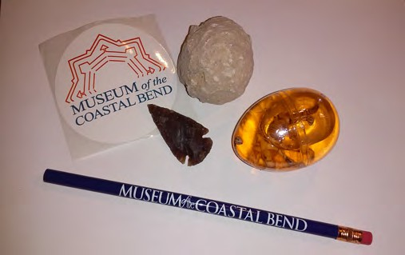
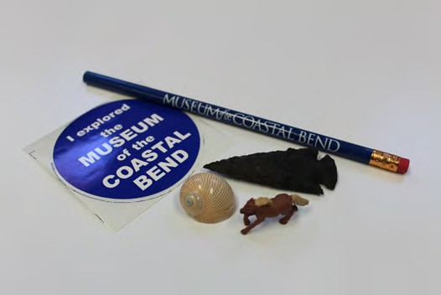
Museum Souvenir Bags

Pre-order for your group to avoid hassle during your visit!

$1 bag contains:
- dart point
- sea shell
- small horse figurine
- MCB pencil
- MCB sticker

$5 bag contains:
- dart point
- dinosaur egg slime
- break your own geode
- MCB pencil
- MCB sticker

(Contents may vary depending upon inventory)
To order, please contact:
Claudia Moseley, (361) 582-2559, Claudia.Moseley@VictoriaCollege.edu

Museum of the Coastal Bend
2200 East Red River • Victoria, TX 77901

