Spanish Presidios and Missions

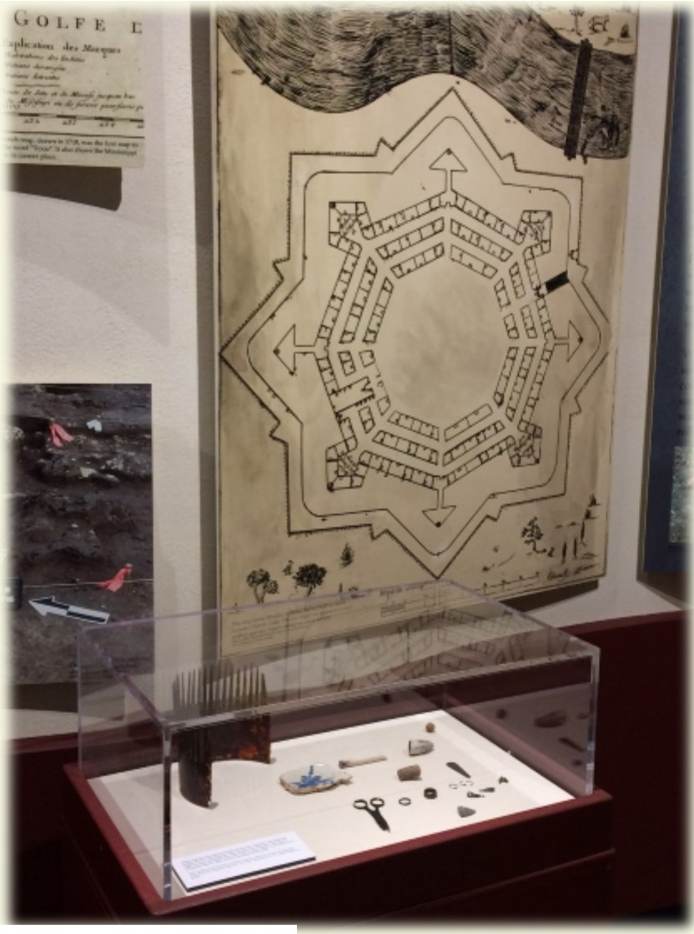
The Spanish discovered Fort Saint Louis in 1689. By this time, the fort was no longer inhabited, but the Spanish found the remains of three people: Isabelle Talon, the Marquis de Sablonniére, and a youth of unknown identity. The Spanish buried the bodies and the cannons and burned the buildings.

In 1722, about 30 years after discovering the empty Fort Saint Louis, the Spanish returned to the site and built Presidio La Bahia. They were unable to find the French cannons that were buried 30 years prior, and the cannons, currently on display at the museum, remained buried until the 1990s.
After building la Bahia, the Spanish also constructed Mission Nuestra Senora del Espiritu Santo de Zuniga on Garcitas Creek across from the presidio. Some historians believe that, while there were plans for the mission to be built at this location, it was never actually built. From approximately 1725-26, the mission was located in what
is now Riverside Park on the Guadalupe River. Both the mission and the presidio moved to Mission Valley and remained there until around 1749. The final move for the mission and presidio was to Goliad where they remain today.
The museum features a variety of Spanish artifacts including jewelry, scissors, and a chocolate pot.

