Texas’ First Peoples
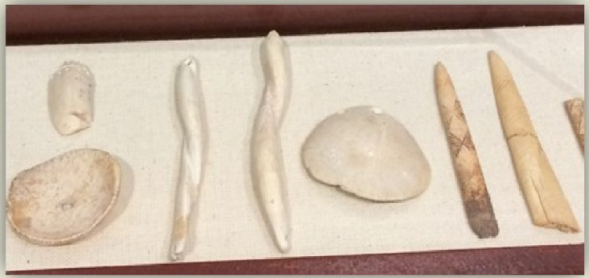
The first peoples of Texas came to this area approximately 13,000 years ago, and the only way for us to learn about them is through the archaeological record. At this time, early people had not yet developed a written language.

Instead of written records, soil samples, stone and shell tools, some decorative items, bones, and other objects that survived biodegrading help us understand the history of early peoples. As you walk through the exhibit space you will see several different styles of projectile points, both arrow and dart, stone tools, and decorative shell pieces.

One of the primary hunting tools used by the early Texas peoples was the atlatl, which means "spear-thrower." The atlatl allowed the early peoples to throw their darts further and with more force than just using their arm, which was especially important when the game they hunted consisted of mammoths
and mastodons. At the museum, you can get a first-hand atlatl experience. Just ask at the front desk and try one out for yourself. How well would you have done 13,000 years ago?

