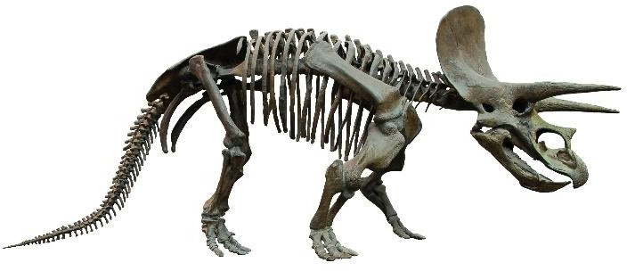

Can You Dig It?
(Recommended for grades K-5)
Excavation is the process by which archaeologists dig up artifacts for study. Now it’s your turn to be the archaeologist! You’ve just come upon a very promising dig site and need to start
“excavating” to see what you can find. Complete the activity below to start excavating your own dinosaur fossil.

What you need:
- Cornstarch
- Water
- Toy dinosaur fossil skeletons or dinosaur figure
- Small plastic food storage container (preferably for lunchmeat storage)
- Small paint brushes
- Toy hammers and digging tools (plastic scraper or Play-Doh spatula would work well)
- Wax paper or cookie sheet

Activity:
- Mix up cornstarch and water in plastic food container. Be sure to mix up enough to fill the container 3/4s of the way up. Use 2 cups of cornstarch and 1 cup of water. (add more cornstarch if mixture is too soupy)
- Place dinosaur skeleton or figures in mixture covering them completely. Be sure to place it as deep into the mixture as possible.
- Place the container out in direct sunlight for 1-2 days until the mixture has hardened. (When cracks start to form, the mixture is ready)
- Place your wax paper or cookie sheet on a flat surface along with your exaction tools.
- Take the plastic container with the mixture and place it face-down on the wax paper or cookie sheet.
- Tap on the top of the container to loosen the mixture and remove the container after the solid block falls on the wax paper.
- Use your hammer to crack open the block and your scraper/spatula to start separating the block.
- Remove the dinosaur skeleton or figure and begin removing the dust particles using your paint brushes until it is all off.
- Left over bits of mixture are fun to play with after your dinosaur has been excavated.

Happy Excavating!

