How Do We Survive?
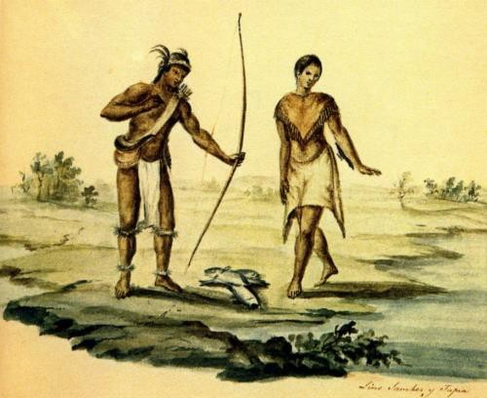

The people of Texas have always been a resourceful bunch. This includes our historic Native Texans. The ability to use the resources that nature and the Texas environment provide is known as resourcefulness. Resourcefulness supplied Native Texans with necessities like food, water and shelter. How is the resourcefulness of the people of the past the same/different to those that live today?

Activity:
Answer the following questions comparing the survival needs of ancient peoples and people of today.
- What are some basic things that people need to live? (List them below)

- How do people today get the things that they need to survive? (Think about how you and your family survive)

- How would a person who lived in ancient times in Texas, before stores and electronics, get the necessary things to survive?

- How are the ways that people in ancient Texas survived similar to how we survive today? How are they different?

- Finding a place to live in early Texas was very important to people back then. How do you think they decided where to live? Give three reasons why.

